

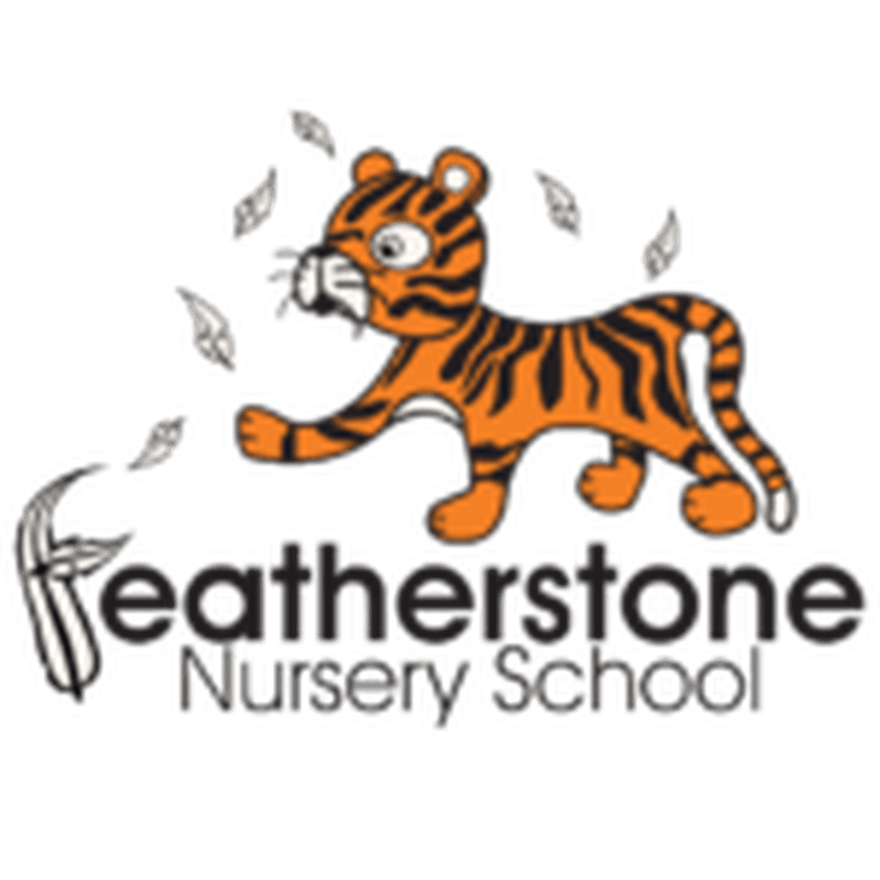

Autumn 1 - Autumn and the Seasons. Me and My Family.
Federation of Osborne and Featherstone Nursery Schools Curriculum Guide for Parents and Carers
2 Year Olds | 3 Year Olds | 4 Year Olds
Key Activities:  Learning names, pointing to pictures of their family, learning their group name, exploring the nursery, learning to use the sand pit and the water tray. Begin to access activities in Forest School. Know who their Key Worker is. | Key Activities:  Talk about things they like to do at home and nursery, understand and follow the rules of the setting, learn names of rooms, areas and people.  Talk about autumn colours and changes that happen. Learn new skills in Forest School. | Key Activities:  What do we have in common—two eyes, two ears. What is different about us? What talents do we have?  Families are different but they love us.  Learn about keeping warm outside and describing seasonal change. Describe what happens in autumn.
Core books to read:  Dear Zoo, by Rod Campbell, Maisy and Bedtime by Lucy Cousins.  Simple picture books and flip, flap books | Core books to read:  Owl Babies by Martin Waddell and Patrick Benson, The Owl Who was Afraid of the Dark by Jill Tomlinson, My Mum is Fantastic, My Dad is Brilliant by Nick Butterworth, This is Our House by Michael Rosen and Bob Graham. Non– fiction books about autumn. | Core books to read:  My Mum by Anthony Browne, Double Love by Ashley and Carol Thomas, Full, Full of Love by Trish Cooke, My Daddy is a Giant by Carl Norac.  Non– fiction books about the seasons and changes.
Important words to learn:  Nursery group name, Key worker’s name, friends’ names.  Verbs: stop, play, choose, now, next, share  Body parts– eyes, nose, head, ears etc | Important words to learn:  Language to describe what they can see outside - blue/grey sky, trees, leaves, falling, crunch  Use language to describe what we look like - tall, blue eyes, brown hair, long, short, two hands | Important words to learn:  I am good at …….  Who, what, where, when, why…  Descriptive language—describe how we look, describe the seasons– falling leaves, wet, colder. Name different plants and trees.
How can you help at home? Talk about family—what are their names? Talk about Nursery.  Name objects in the house and encourage your child to ‘use their words’! | How can you help at home? Talk about what they like to do at home. Encourage them to talk about their experiences at Nursery  Go for walks—what do you see? | How can you help at home? Go for a walk in the park—can you name the trees? Conifer, oak, chestnut. Describe the colours you can see. Ask questions! Encourage your child to speak in full sentences and add detail.

